Practical Geometry Worksheet 1 Date :

1. Draw a circle of radius 5.6cm
2. With the same centre O, draw two circles of radii 5cm and 2.5cm
3. Draw any circle and mark points P, Q and R such that
a) P is on the circle
b) Q is in the interior of the circle.
c) R is in the exterior of the circle.
4. Draw a line segment of length 10.8cm. Using compasses, divide it into four equal parts . Verify by actual measurement.
5. Fill in the blanks :-
i) If diameter of a circle is 18cm, the radius is _____________.
ii) The longest chord of a circle is _____________ .
iii) Number of circles passing through a given point are ___________.
6. Solve
Given AB = 3cm & CD = 4cm, construct a line segment xy equal to sum of AB & CD
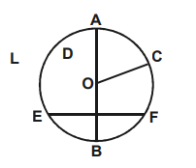
7. Refer to the figure given below, answer the following.

i) Name any radius of the circle ____________
ii) Name centre of the circle ____________
iii) Name any segment of the circle ____________

8. With $\vec{AB }$of length 6.2cm as diameter, draw a circle
9. Draw a circle of radius of 4.7 cm?

10. If the radius of a circle is 8.5 cm, then the diameter of the circle is ____.
  - None of these
  - 17 cm
  - 12 cm
  - 8.5 cm

